14. Determination of the Shape Factor of a Paleo-Stress Ellipsoid
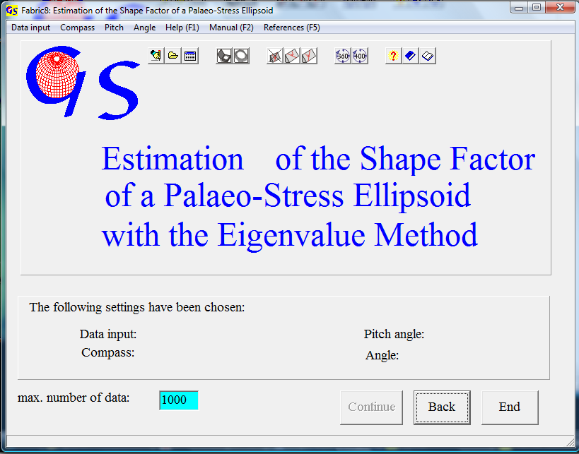Fig. 1

The program 14 (Fig. 1) allows the estimation of the shape factor "R" of a distribution of displacement data (see program 13) after WALLBRECHER et al. (1996). Using Bott’s formula (BOTT, 1959) all theoretical striation directions on the measured slickenside planes are calculated for R = 0.0, 0.1, ...,1.0. For these theoretical populations of striations the eigenvalues are calculated and plotted in a triangle plot. The eigenvalues of the measured striations are calculated as well and plotted in the triangle. By visual interpolation the R-Value can now be estimated. For the calculation the orientation of the principal stresses must be known. That means that the data set has first to be treated with program 11. In addition the data should be checked for consistancy with program 13, and non fitting data should be eliminated. Since the type of data is identical with that of programs 11, 12, and 13 the menus of the starting form and data input are the same as in these programs.

The graphic form (Fig. 2) plots a data set which already had been cleaned with program 13. The principal stresses were estimated with program 11. They are σ₁ = 80/35 und σ₃ = 180/10. For the remaining slickenside planes the eigenvalues of the orientation matrices of theoretical striations were calculated for various R-values. In addition the eigenvalues of the orientation matrix of the measured striations was calculated. Since the sum of the normalized eigenvalues is of each data set is always 1, they can be plotted in a triangle diagram. The theoretical eigenvalues are blue the measured ones are red. Theoretical and measured eigenvalues are also listed in the table on the right side of the form.
A visual comparison of the measured values with those for the shape factors R = 0.0....1.0 results in a shape factor of
R ~ 0.9.
If the data set is consistent, all dots should lie on a line and the measured dot should be close to this line. (WALLBRECHER et al., 1996).

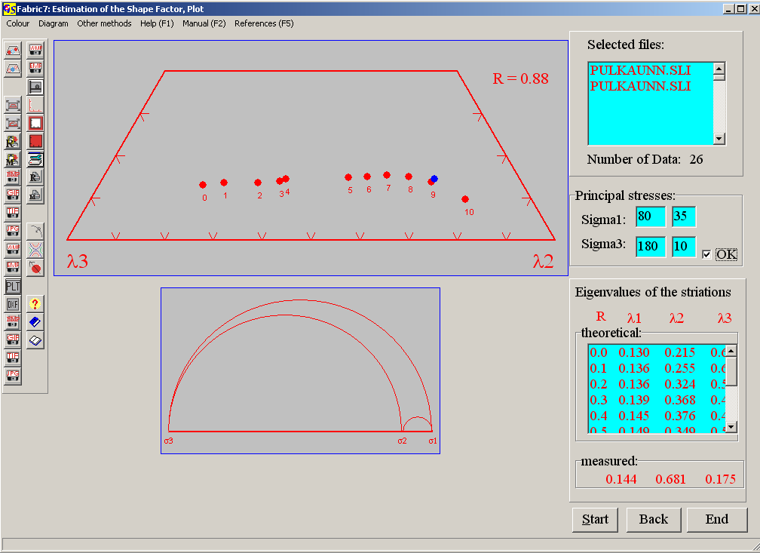 Fig. 2

The menu "Diagram" is described in Program 3. With the menu "Other methods" you can jump to the other programs which use displacement data.

